

**Faculty of Engineering & Technology – Electrical & Computer Engineering Department**

**First Semester 2022 – 2023**

**Circuits and electronics lab**

**ENEE2103**

**PRELAB EXP.2**

**Name: Amal Ziad**

**ID: 1192141**

**Section: 2**

**Instructor: Dr. Nasser Ismael**

**TA: Eng. Yazan Yousef**

**Date: 4th Nov 2022**

**Part 1- Kirchhoff’s Laws (KVL and KCL)**

1. When Rx = 1 k Ω:

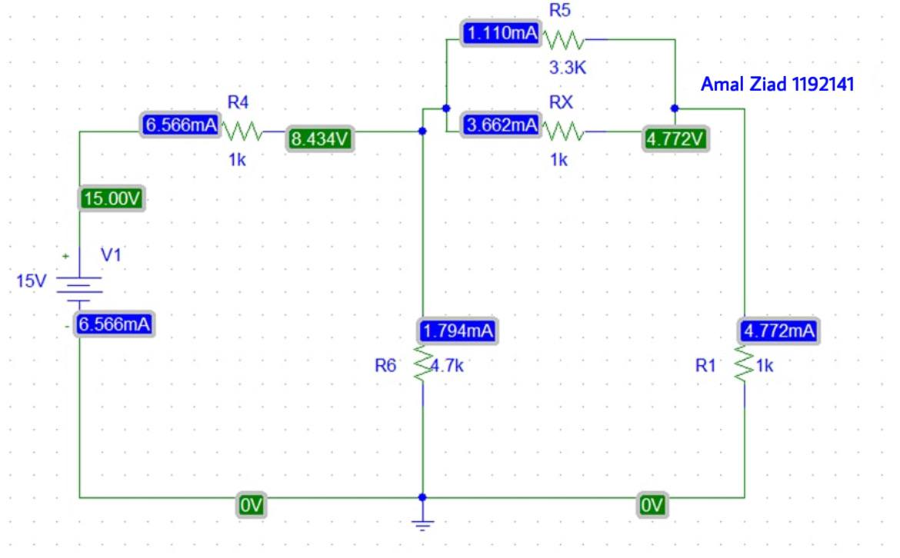

1. When Rx = 0.5 kΩ:

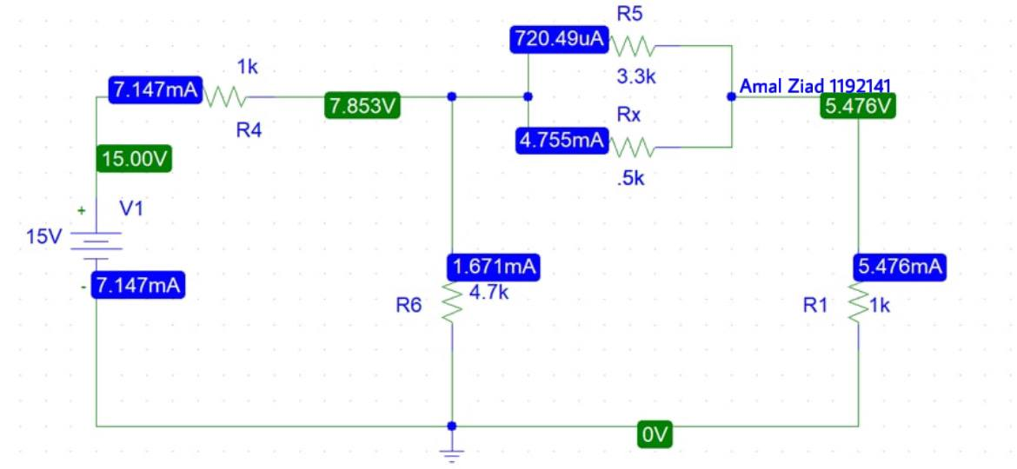

**Part 2.1-Voltage division**

a- When Rx = 1kΩ:

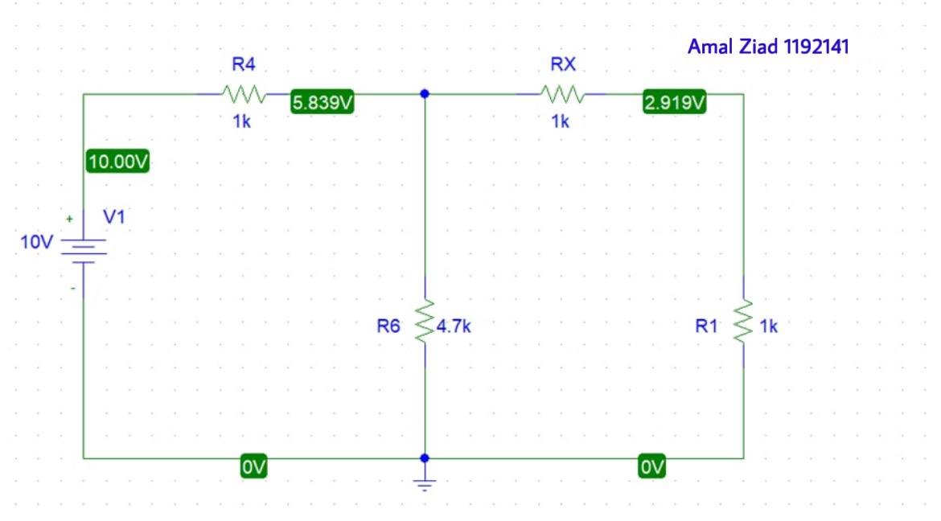

b- When Rx = 0.5 k Ω:

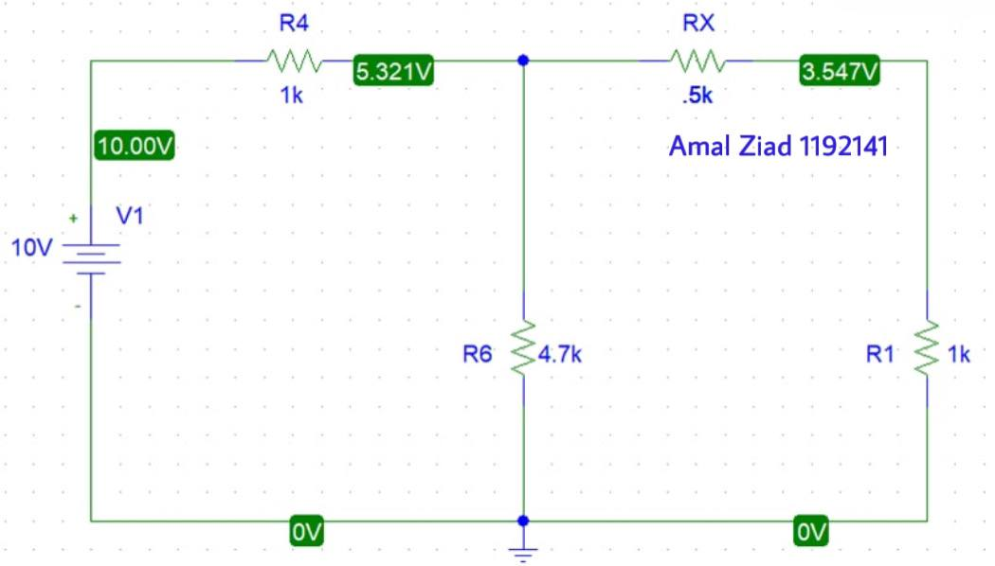

**Part 2.2- Current division**

a- When Rx = 1 k Ω:

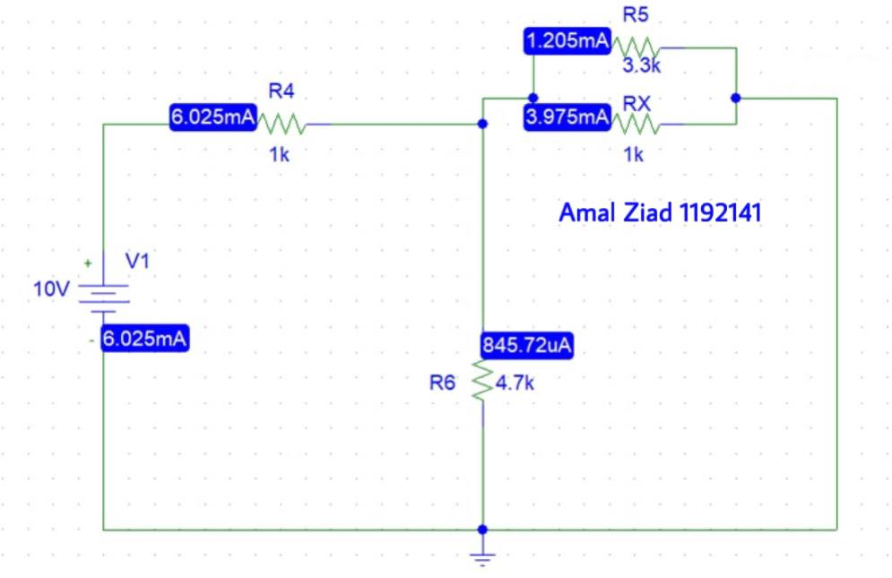

b- When Rx = 0.5k Ω:

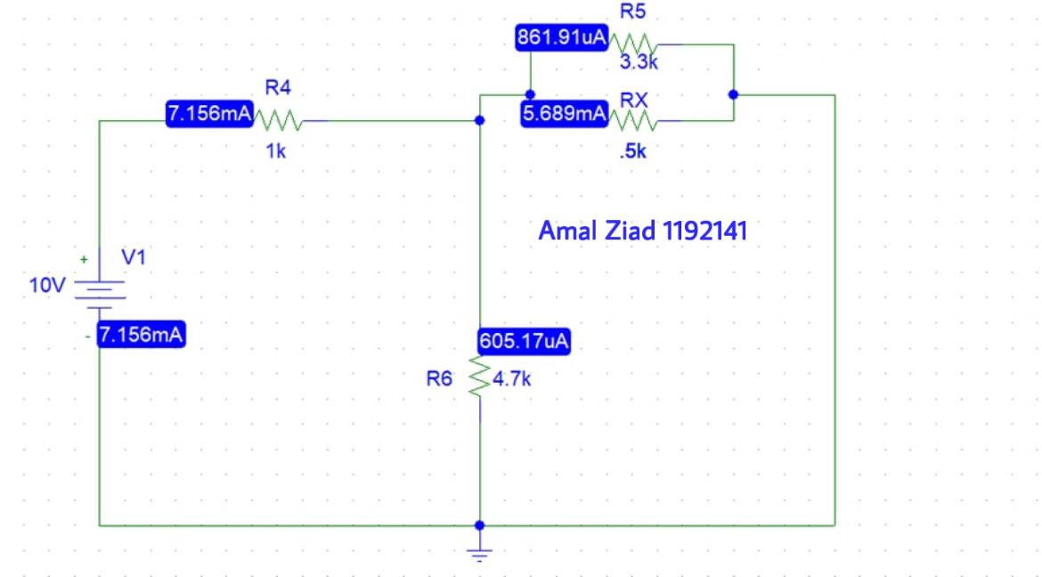

**Part 3-Superposition**

1. Circuit without removing any source:

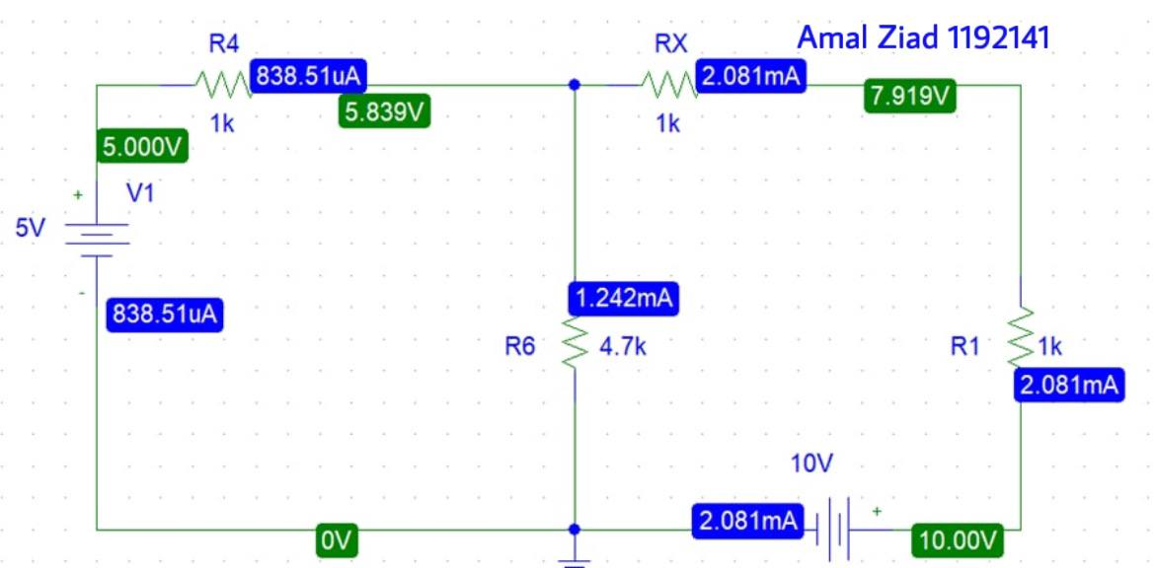

1. Circuit after killing Vs1:

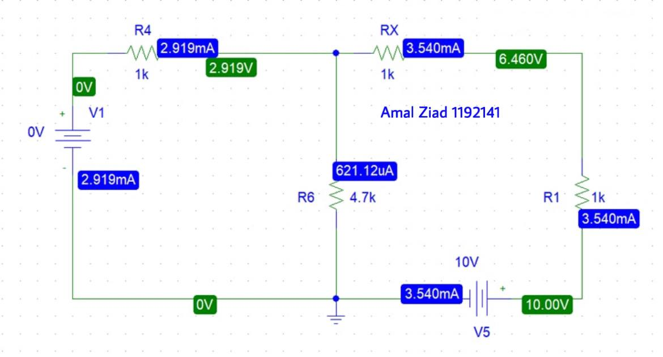

C- Circuit after removing Vs2:

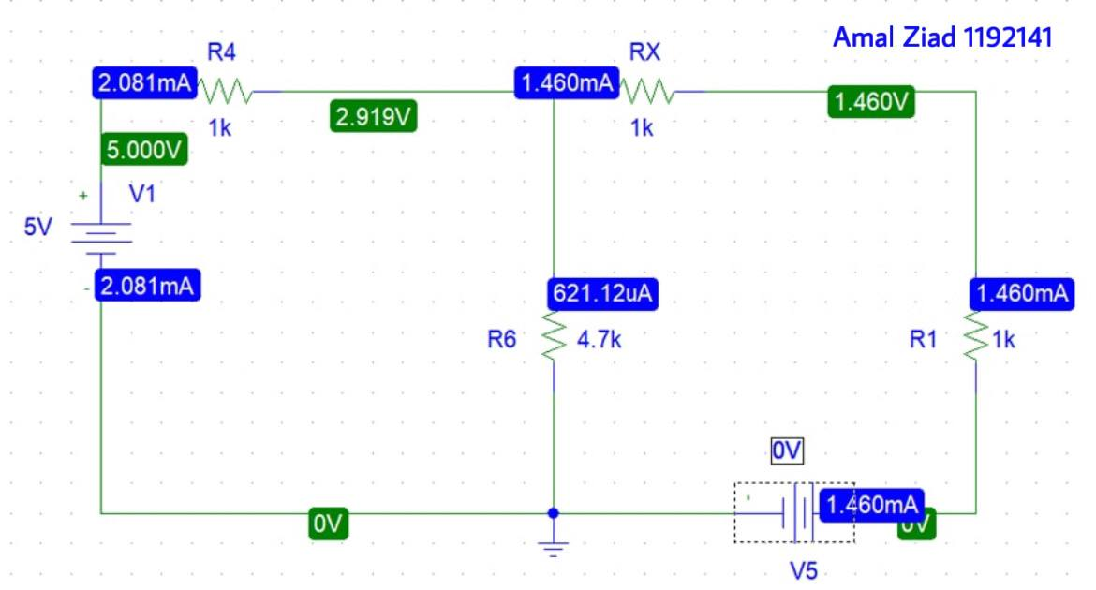

**Part4- Thevinin equivalent circuit**

1. Finding voltage in R1 in the origin circuit:

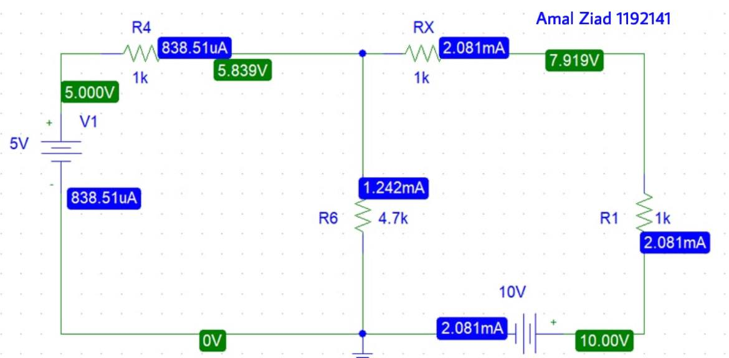

VR1 = 2.081 V.

1. Finding Voc ”Vth” :

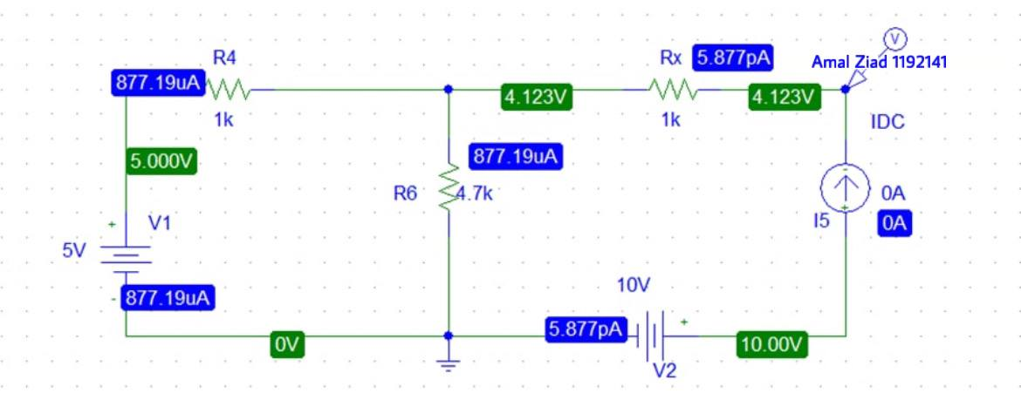

Vth = 10 - 4.123 = 5.877 V.

1. Finding Rth by using dc sweep graph and measuring the slope:

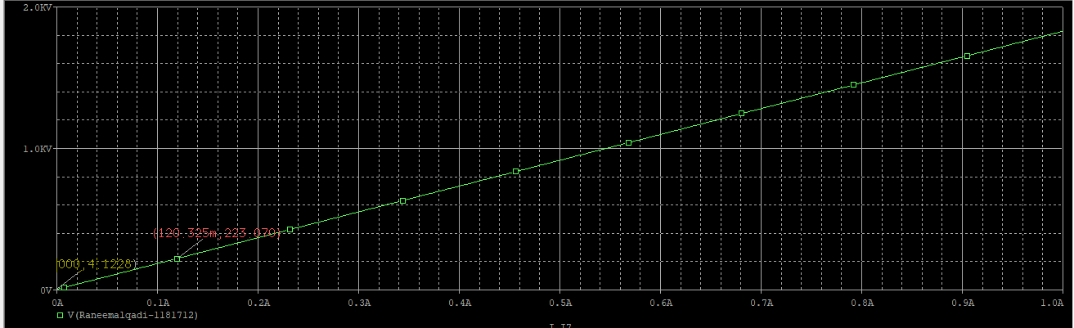

Slope = $\frac{223.070-4.1228}{120.325-0}$ = 1.8196 ≈ 1.82 k Ω

Rth = slope = 1.82 k Ω.

4- Finding Isc:

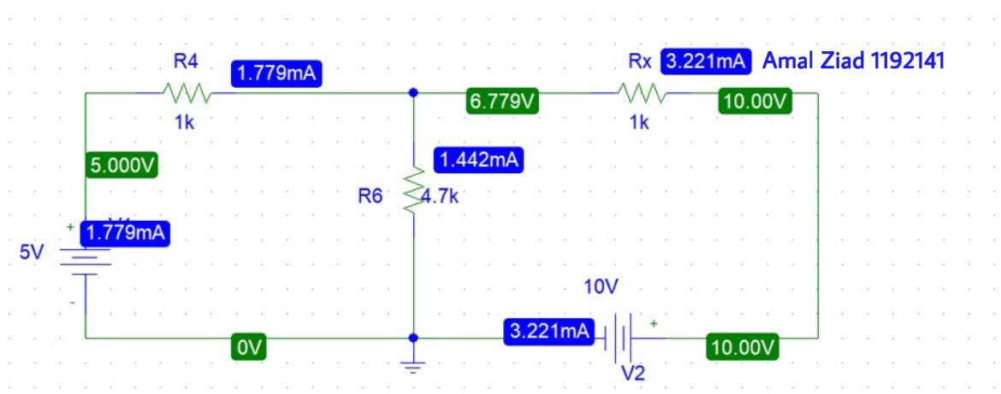

Isc = 3.221 mA.

5- Finding Isc in the equivalent circuit:

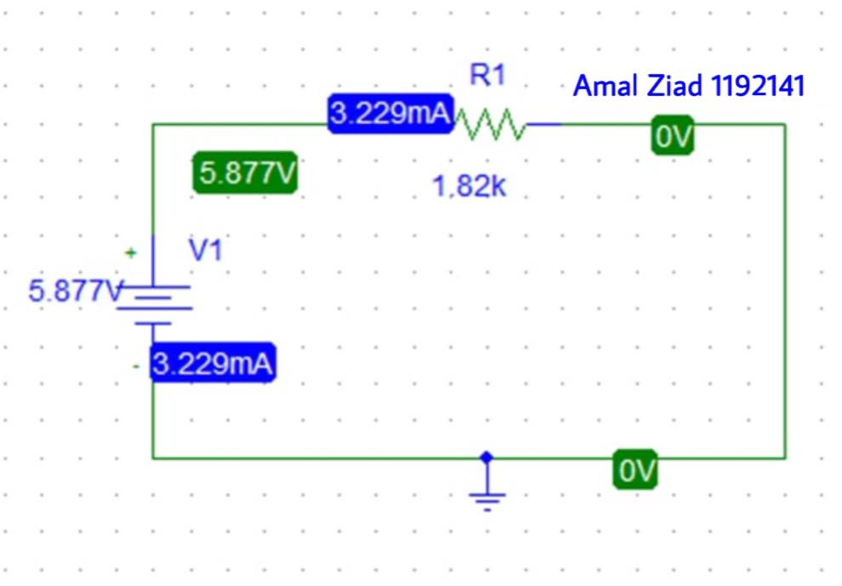

Isc = 3.229 mA.

6- Finding Voc in the equivalent circuit:

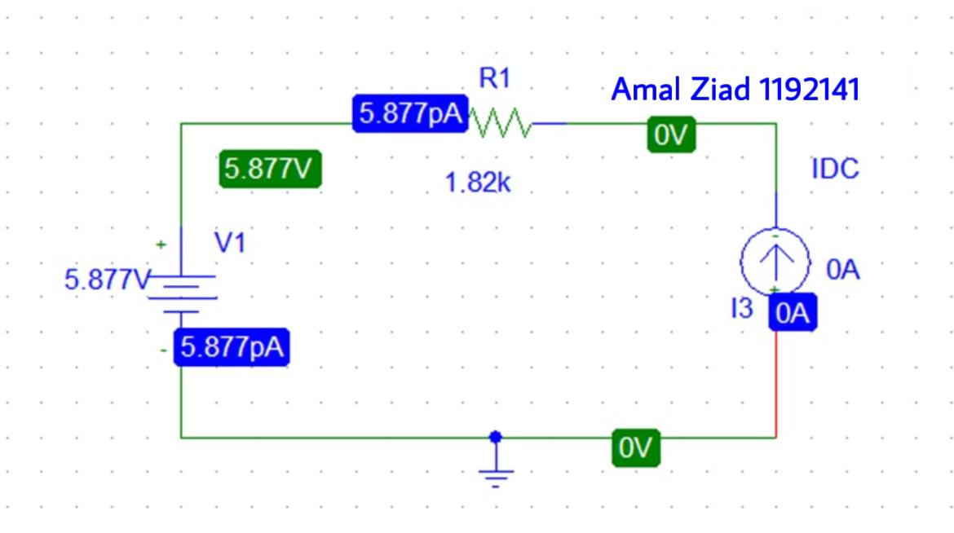

Voc = 5.877 V.

7- Reconnecting RL in the equivalent circuit:

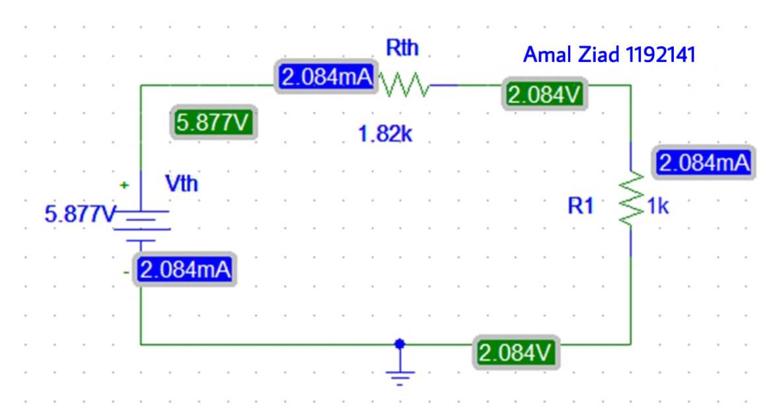

**Note:** VR1 in the equivalent circuit matches VR1 in the origin circuit so this is the aim of Thevenin circuit.